|  |  |  |  |
| --- | --- | --- | --- |
|  | | Executive Summary  Aqua Scientia Potentia Est - Water Knowledge is Power | |
| AquaSPE is the founder and operator of the largest online knowledge sharing platform  and business exchange for the $700 billion water sector | | |
| TheWaterNetwork.com | * Members from 195 countries   75% with advanced degrees  50% in managerial roles   * 150,000 page views per month * > 200,000 newsletter subscribers * Over 10,000 companies * 350 Technology editors & world-class advisors * Multimedia library   > 6000 posts   * Q&A knowledge bank   500,000 views   * Thematic workgroups   165   * Events   1900 | |
| [Background](http://www.worldbank.org/en/topic/water/overview) Solving the world’s water crisis requires collaboration and innovation. Estimates show that the world will face a 40% shortfall between forecast demand and available supply of water by 2030.   * > 1 billion people without access to safe drinking water * 30% of all people have no basic sanitation or toilets * 70% of fresh water needed for agriculture * 50% of our energy resources to move and treat water * Lack of access to fresh water limits human development and economic growth   **Solution**  The Water Network to connect the collective intelligence of global water professionals online & free for all to join.  **Objectives**  1 million members who resolve 10,000 questions and 100 challenges by 2020. To build a better future.   1. All questions answered within 30 minutes 2. Matchmaking between 500 technology companies and mentors, pilots & investors 3. The trusted source for professional water knowledge | **Value Propositions**  High social impact by creating a global knowledge platform available to all for free.   * For Professionals * Share & discover * Just for me! contextual and personalized * Q&A professionally ranked answers * For companies * Broadest media reach in the water sector * Sales leads and qualified candidates for job openings * For initiatives & interventions * Knowledge sharing | |

©2015 AquaSPE AG – all rights reserved- Trittligasse 12 8001 Zurich Switzerland [contact@aquaspe.com](mailto:contact@aquaspe.com)

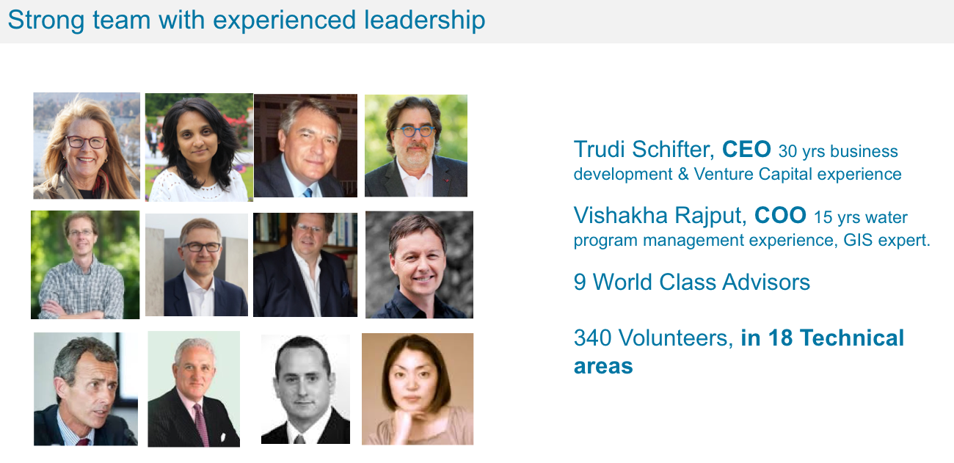

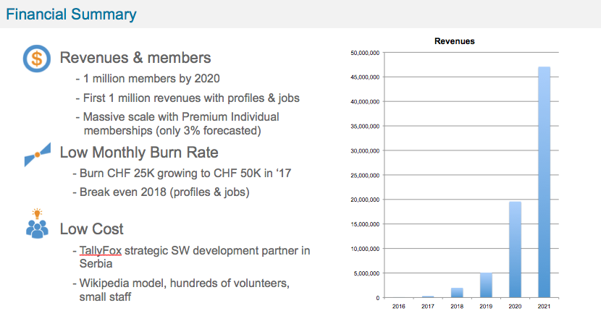

Collaboration and Knowledge Sharing

AquaSPE is a thought leader in building and managing online knowledge centric communities in the water sector for interventions, associations, and projects.

Water communities are provided all that is expected from an award winning collaboration solution plus access to the global Network and SmartMatchProTM.

©2015 AquaSPE AG – all rights reserved- Trittligasse 12 8001 Zurich Switzerland [contact@aquaspe.com](mailto:contact@aquaspe.com)